**TEACH 2030- PLANNING LESSONS TO REACH ALL LEARNERS**

We are delighted you have chosen a Teach2030 course – it’s great to have you here. Our mission is to bring useful, engaging and relevant courses to all teachers, whether you are new to the profession or have many years experience, to help you to regularly review your teaching practice throughout your career. Our courses will provide you with access to high-quality learning materials, that really make you think about why you teach, and how you teach.

**Why lesson planning? Why should we focus on our lesson plans – whether we are new to teaching or have spent many years in the classroom?**

**‘Consistent effective lesson planning is essential for successful experiences in both teaching and learning. Quality teaching, like any other occupation, requires sound rational planning, organisation and management.’ 1**

A good lesson plan serves as a checklist, a way for you as the teacher to ensure you are covering and including all you need to, to help the children you teach learn, and learn well.

In Part 1 of this course you will:

* Reflect on your own learning experiences
* Identify the steps involved in learning something new
* Know why lesson planning is an essential part of a teacher’s role
* Reflect on your own lesson plans
* Begin, or contribute to, your teacher portfolio
* Identify, or continue to work with, a learning partner

And in Part 2 we will:

* Explore writing lesson plans in more depth.
* Break down the process of writing an effective lesson plan
* Focus on each section of the lesson and its value
* Create a lesson plan, incorporating new ideas and techniques to try

**PLEASE NOTE You will need plans from lessons you have taught previously for this course. Make sure you have them with you.**

**Planning Lessons to Reach All Learners Course Objectives**

[**Planning Lessons to Reach All Learners: Part 1**](https://teach2030.com/courses/planning-lessons-to-reach-all-learners-part-1/)  [**Planning Lessons to Reach All Learners Course Objectives**](https://teach2030.com/courses/planning-lessons-to-reach-all-learners-part-1/lessons/planning-lessons-to-reach-all-learners-course-objectives/)

**COMPLETE**

* To reflect on your own learning experiences
* To identify the steps involved in learning something new
* To know why lesson planning is an essential part of a teacher’s role
* To reflect on your own lesson plans
* To begin, or contribute to, your teacher portfolio
* To identify, or continue to work with, a learning partner

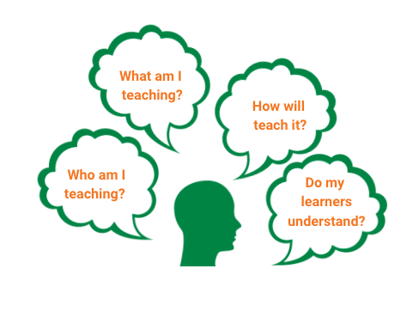

**The Structure of Teach2030 Courses**

[**Planning Lessons to Reach All Learners: Part 1**](https://teach2030.com/courses/planning-lessons-to-reach-all-learners-part-1/)  [**The Structure of Teach2030 Courses**](https://teach2030.com/courses/planning-lessons-to-reach-all-learners-part-1/lessons/the-structure-of-teach2030-courses/)

**COMPLETE**

So, what will you find in every Teach2030 course? They all contain the following:

* **How to build a teaching portfolio**

All teachers who are committed to their professional development should consider keeping a teacher portfolio; that they can continue to build on throughout their career. When teachers select an entry for their portfolio, not only do they have to think or discuss, but they also need to write down their ideas and reflections. Reflective writing provides teachers with an opportunity to focus, organise, edit their ideas, and finally to reflect upon them in print. And, perhaps most importantly, the written documents are always available to be reviewed, and to serve as clear evidence of the teacher’s thinking, reasoning, and actions.1

* **The importance of a learning partner**

We believe that talking to our peers is one of the best ways to learn and improve.

* **Pedagogical theory**

All Teach2030 courses are based on solid evidence and research that is mapped to Cambridge Teaching Standards; you can be confident that the theory, information and strategies in this course all demonstrate best teaching practice.

* **Practical classroom activities (both long and short tasks)**

All activities are suitable for all classrooms, in all contexts, and they all provide opportunities for discussion and development of teaching practice. They are signified with the image of a pencil.

* **Videos explaining theories or demonstrating techniques/strategies**

Teach2030 videos are short, clear and perfect for discussions. For example, they show how to give effective feedback, or what a growth mindset looks like in your teaching.

* **Creating an action plan**

We believe strongly in the power of an action plan, so all courses ask teachers to consider which learning points they would like to take from the course, and how they plan to apply them to their practice.

* **Downloadable resources**

All activity tables and reading can be downloaded and printed off, if required. Otherwise, notes and tables can be jotted down easily.

# How a Teacher Portfolio Supports Your Teaching

[**Planning Lessons to Reach All Learners: Part 1**](https://teach2030.com/courses/planning-lessons-to-reach-all-learners-part-1/)  [**How a Teacher Portfolio Supports Your Teaching**](https://teach2030.com/courses/planning-lessons-to-reach-all-learners-part-1/lessons/how-a-teacher-portfolio-supports-your-teaching/)

**COMPLETE**

**Keeping a teaching portfolio is not compulsory but we think that it is an essential way of demonstrating your learning and progress as a teacher during the time you spend on the course.**

Teach2030 provides you with information and new ways of thinking about teaching. We can acknowledge your completion of a course with a certificate but this will not show how you have embedded the techniques.Your portfolio is an opportunity to demonstrate your learning and how you have developed your teaching.

Your teacher portfolio is also something that might be useful in the future, as additional evidence of your willingness to self-improve. Employers should be impressed by your organisation skills and clear outlining of your interests/capabilities as a teacher. It is useful to reflect on what you have learnt and document evidence of your studies for further education courses; it may even help to prepare you for interviews.

**Creating a Teacher Portfolio**

[**Planning Lessons to Reach All Learners: Part 1**](https://teach2030.com/courses/planning-lessons-to-reach-all-learners-part-1/)  [**Creating a Teacher Portfolio**](https://teach2030.com/courses/planning-lessons-to-reach-all-learners-part-1/lessons/creating-a-teacher-portfolio/)

**COMPLETE**

These are suggested sections for your teacher portfolio. Create a file and underneath each sub-heading, try to place the following information:

1. **All About Me**:

* name
* school
* grade/subject taught
* qualifications
* previous job roles
* any responsibilities

2**. My Teaching Philosophy**

A document that outlines your:

* goals as a teacher
* reasons for becoming a teacher
* approach to teaching and career progression
* viewpoint on how to teach effectively
* preferred teaching methods/strategies
* challenges faced when teaching.

**3. Workshops / Training attended**

* A record of any training that you have attended should include dates, worksheets and follow-up activities.

**4. Evidence of Change/Progression of Skills**:

* examples of where you have changed your teaching practice after training, research, classroom observations etc.
* samples of learners’ work, lesson plans, photographs etc.

5. **Lesson Observations**:

* evidence  of  any  lesson  observations  from  your  peers  or  senior  leadership  team.
* plans for developing the areas identified in observations as requiring improvement.

**6. Lesson Plans/Reflections**:

* examples of lesson plans
* examples of lesson reflections (completed after teaching the lesson)
* areas where you have included new strategies or techniques.

**7. Assessment**:

* a record of learners’ assessments/marks to help monitor progress
* a record any assessment strategies that you find effective (and why)
* appropriate markschemes (if applicable).

**8. Professional Development Action Plan**

A list of teaching practice areas that considers:

* the areas you would like to improve
* the method of improving these areas, e.g. peer observations, planning, training etc.
* the frequency that you will visit your own action plan and how you will monitor progress.

**9. Subject Knowledge Action Plan**

A list of subject specific information that documents:

* the topics you are confident teaching
* the topics you need further expertise in
* the method of developing this knowledge; it might be worth considering who in the department could assist you with specific gaps.

**10. Personal Interests**

* Any articles, newspaper clippings and photographs that you would like to reflect on as a teacher.

**This teaching portfolio should be continually updated. It will become vital evidence for your career progression.**

# Teacher Portfolio: Summary

[**Planning Lessons to Reach All Learners: Part 1**](https://teach2030.com/courses/planning-lessons-to-reach-all-learners-part-1/)  [**Teacher Portfolio: Summary**](https://teach2030.com/courses/planning-lessons-to-reach-all-learners-part-1/lessons/teacher-portfolio-summary/)

**COMPLETE**

**Why keep a teacher portfolio?**

It demonstrates:

1) Your own personal philosophy of teaching

2) Evidence of your learning from training you have received

3) Opportunities to record your self-reflection on areas of strength and those that need developing.

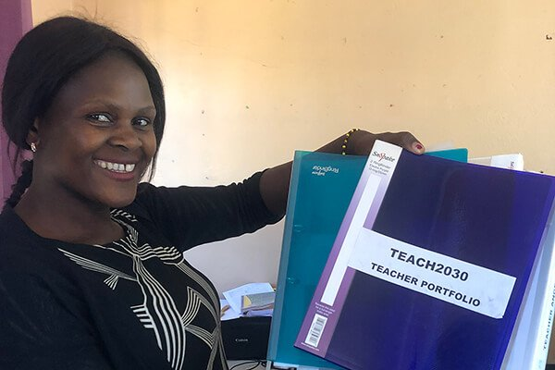

It serves as a continuous tool to reflect, evaluate and monitor your own teaching and performance, in order to develop your teaching skills and continue to raise learning outcomes for the children you teach.

Here is the Teach2030 coach Hope Chiundira from Chishawasha School, Central Province, Zambia with her teacher portfolio.

# The Importance of a Learning Partner

[**Planning Lessons to Reach All Learners: Part 1**](https://teach2030.com/courses/planning-lessons-to-reach-all-learners-part-1/)  [**The Importance of a Learning Partner**](https://teach2030.com/courses/planning-lessons-to-reach-all-learners-part-1/lessons/the-importance-of-a-learning-partner/)

**COMPLETE**



Humans are social animals, and we often learn best from each other. We would like to encourage you to find a learning partner, if you haven’t already done so. This should be a fellow teacher. They could be more or less experienced than you, or have been teaching for the same amount of time; their experience isn’t important. Try not to worry if if the person teaches the same age group or subject as you – a cross curricular approach can be extremely beneficial.

Why do Teach2030 courses suggest you have a learning partner?

Everyone needs someone who; supports, advises, challenges, listens, and celebrates our achievements.  
As teachers, we all have experiences and ideas to share with others. By discussing what we are doing, we pass on our own knowledge through informal conversations and our everyday teaching practice.

**Good learning partners…**

* Respect each other.
* Listen without judgement.
* Collaborate and value learning from each other.
* Provide a safe space to discuss lessons that went wrong, or need improving.
* Help each other with their mission to become even better teachers.
* A learning partner could be someone who is experienced, or someone new to teaching. It is not only about subject knowledge or years of expertise, it is also about attitude and the sharing of ideas.

**So, who will be your learning partner? Find one today, and participate in your Teach2030 course togethe**r!

# Who Will Be Your Learning Partner?

[**Planning Lessons to Reach All Learners: Part 1**](https://teach2030.com/courses/planning-lessons-to-reach-all-learners-part-1/)  [**Who Will Be Your Learning Partner?**](https://teach2030.com/courses/planning-lessons-to-reach-all-learners-part-1/lessons/who-will-be-your-learning-partner/)

**COMPLETE**

**You could use this table to find a colleague with the right qualities to be a successful learning partner**.

**Consider** your colleagues: who you think you would work well with? Look at the qualities listed on the table and assess how many of them you think they have. More than five and they should be a suitable, positive partner to help develop your teaching practice. It is worth noting which of these qualities you have, alongside any you might need to work on yourself.

|  |  |
| --- | --- |
| helpful | approachable |
| keen to improve their own practice | motivated |
| patient | encouraging |
| enthusiastic | conscientious |
| supportive | determined |
| self-reflective | will keep you on track |
| available | a good listener |
| observant | responsible |

For each Teach2030 courses, you can either remain with or change your learning partner. Try to stay with the same person for the full course. The more activities you complete together, the stronger your relationship will become. This will lead you to being more honest and open with each other, which will only improve both of your teaching practices further.

Getting to Know Your Learning Partner

[**Planning Lessons to Reach All Learners: Part 1**](https://teach2030.com/courses/planning-lessons-to-reach-all-learners-part-1/)  [**Getting to Know Your Learning Partner**](https://teach2030.com/courses/planning-lessons-to-reach-all-learners-part-1/lessons/getting-to-know-your-learning-partner/)

**COMPLETE**

When beginning to work closely with a colleague, it can take time to feel comfortable. Here are some ice-breaker activities to help you to create an effective partnership. During your first session of working together, they can be a good way of getting to know each other, although it is always a relaxing way of easing into a new course.

**10 Things in Common**

Identify ten things you have in common with your new learning partner. You can’t choose easy answers such as ‘ we both have hands!’ This activity enables you to have direct conversations and find some similarities (and differences) between you both.

**Fun and Funny Questions**

Choose one question (or think of your own) to get the conversation going. They are designed to encourage you to chat in depth.

* If you were a vegetable, what vegetable would you be?
* If you woke up tomorrow as an animal, what animal would you choose to be and why?
* Are you sunrise, daylight, twilight, or night? Please share why you picked your time of day.
* If you could choose to stay one age forever, what age would you choose and why?

**Two Truths and a Lie**

This is great fun. Declare two true facts about yourselves and then make something else up: the lie! Your partner has to decide which one is the lie by asking lots of questions to try and work out the truth!

**How Good Are Your Instructions?**

[**Planning Lessons to Reach All Learners: Part 1**](https://teach2030.com/courses/planning-lessons-to-reach-all-learners-part-1/)  [**How Good Are Your Instructions?**](https://teach2030.com/courses/planning-lessons-to-reach-all-learners-part-1/lessons/how-good-are-your-instructions/)

**COMPLETE**

Now you have found your learning partner, it’s time to start working together.  This next short and engaging activity shows the importance of clear explanations and directions – a key component of a successful lesson. Instructing can be challenging, as it is easy to misunderstand or misinterpret information if we are not clear and precise.

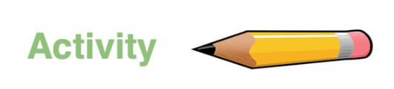

One of you should choose an object that you know is simple to draw. It could be a house, a car, a ladder and so on. Draw it yourself first on a piece of paper but do not show it to your partner.

Describe to your learning partner how to draw the object you have drawn, but **DO NOT say WHAT** you are drawing. For example, if drawing a flower, your instructions might be ‘First of all draw a long line in the middle of your page. Put your pencil at the bottom of the line and draw a triangle pointing outwards. Then draw another triangle starting in the same place, but pointing in the other direction. At the top of the line draw a circle. Draw lots of smaller circles around the outside of the first circle’.

When you have finished, compare your original drawing with your partner’s.

* How successful is the picture?
* Why doesn’t their picture look like the original?
* What were your frustrations as the person giving the explanation (giving instructions), and as the receiver of the explanation?

NB Possible discussion points: everyone has a different interpretation, directions were not clear, not able to give or get feedback.

Now, swap roles. It is the turn of the learning partner to give the explanation of what to draw. However, this time tell them what they are drawing, and the person drawing can ask questions and receive answers.

Again, compare the drawing to the original.

* Did it help to be able to watch the person drawing?
* Did it help to be able to ask questions?
* Did it help to know what the objective is/ what you had to draw?

**Consider this activity in the context of how you teach.**

Are you always clear with your lesson objectives? Do your learners know what they have to do? Or what they are going to learn? Do you give them feedback throughout the lesson to support them?

Write down your thoughts and keep them in your teacher portfolio.

# Why is Planning So Important?

[**Planning Lessons to Reach All Learners: Part 1**](https://teach2030.com/courses/planning-lessons-to-reach-all-learners-part-1/)  [**Why is Planning So Important?**](https://teach2030.com/courses/planning-lessons-to-reach-all-learners-part-1/lessons/why-is-planning-so-important/)

**COMPLETE**

The previous activity helped us reflect on how valuable clear instructions are, knowing the objective and getting feedback – all key ingredients of a successful lesson.

This course asks you to really **think**about the lessons you plan, how effective they are, and how you can improve what you already do.

We like these quotes!

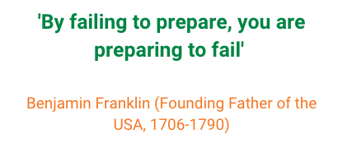

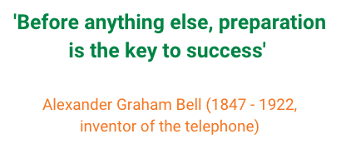

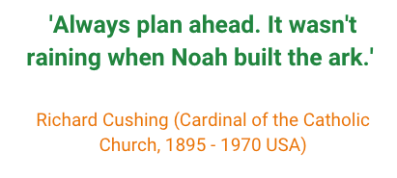

What do you think of these quotes? **Discuss with your learning partner.**

The aim of this course is to ensure you create meaningful and effective plans that are well-thought through – ones that have clear purpose, both to you and the learners you teach.

**But first – when do you need to plan in your personal life?**

**When did you last learn something new?**Did you learn ….  
A new language?  
A new dance?  
A challenging recipe?  
A new technical skill?  
A different strategy for your classroom?  
Think about these questions….  
What was it that I needed to learn? Why?  
What did I know or need to know before I started?  
Where did I go for help, or to check I was doing it right?  
How did I know I had achieved it?  
Where did I go next?

Learning never stops. Now reflect on when you last learnt something new.

Planning in Your Personal Life

[**Planning Lessons to Reach All Learners: Part 1**](https://teach2030.com/courses/planning-lessons-to-reach-all-learners-part-1/)  [**Planning in Your Personal Life**](https://teach2030.com/courses/planning-lessons-to-reach-all-learners-part-1/lessons/planning-in-your-personal-life/)

**COMPLETE**



Consider **when** and **how** you plan in your personal life. Think back to when you last learnt something new, or had to do something challenging.

Break down the process into these steps.

* What was it that I needed to learn? Why?
* What did I know or need to know before I started?
* Where did I go for help, or to check I was doing it right?
* How did I know I had achieved it?
* Where did I go next?

Write your thoughts down – you might find it helpful to draw a table like the one shown below.**Discuss your thoughts with your learning partner and keep in your teacher portfolio.**

**An example**

|  |  |
| --- | --- |
| What was it that I needed to learn? Why? | I needed to learn how to plant tomato seeds, so I could grow my own tomatoes. I have bought ready grown tomato plants before, but decided it was time to try and plant my own. |
| What did I know or need to know before I started? | I knew the basic conditions needed for seeds to grow, and that I needed to source compost and pots to start with. |
| Where did I go for help, or to check I was doing it right? | I read the back of the packet of tomato seeds, and I asked a friend who is a farmer for help with further questions. She gave me top tips for when to plant the seedlings into larger pots, how much to water them and so on. She also showed me the progress of her seedlings. |
| How did I know I had achieved it? | By producing tomato seedlings big enough to plant outside and yield fruit. |
| Where did I go next? | I decided to use what I know about seeds to start trying to grow other plants from scratch. |

Although this seems a very basic example you can see that what it actually shows is a **simple lesson plan**.

# Personal Planning Broken Down

[**Planning Lessons to Reach All Learners: Part 1**](https://teach2030.com/courses/planning-lessons-to-reach-all-learners-part-1/)  [**Personal Planning Broken Down**](https://teach2030.com/courses/planning-lessons-to-reach-all-learners-part-1/lessons/personal-planning-broken-down/)

**COMPLETE**

Let’s look at the purpose of each section and how it represents each part of a lesson. Could the process you followed in your personal activity fit into the sections below? **Discuss with your learning partner.**

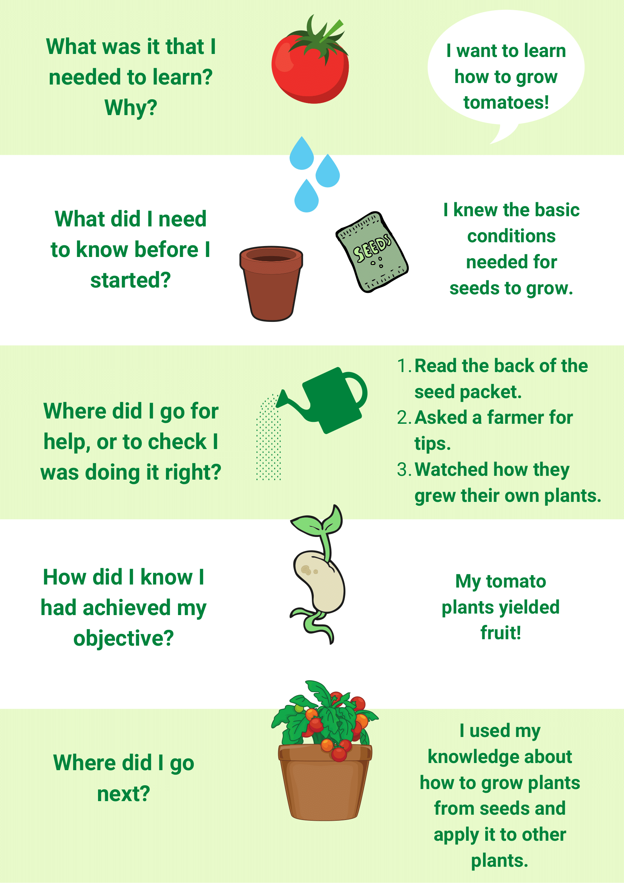

This activity shows us that even without realising it, when we learn something new, we actually follow a basic lesson plan – or we should if we want to learn something well!

So, how can we consider this to ensure we plan effectively for our learners?

# Further Reading on Why We Plan

[**Planning Lessons to Reach All Learners: Part 1**](https://teach2030.com/courses/planning-lessons-to-reach-all-learners-part-1/)  [**Further Reading on Why We Plan**](https://teach2030.com/courses/planning-lessons-to-reach-all-learners-part-1/lessons/further-reading-on-why-we-plan/)

**COMPLETE**

Read the following extract written by Linda Jensen on the importance of planning.

‘Deciding what to teach, in what order, and for how much time are the basic components of planning. The lesson plan serves as a map or checklist that guides us in knowing what we want to do next; these sequences of activities remind us of the goals and objectives of our lessons for our students. A lesson plan is also a record of what we did in class; this records serves as a valuable resources when planning assessment measures. A record of previously taught lessons is also useful when we teach the same lesson again, so that we have an account of what we did the term or year before to avoid reinventing the wheel. Just as teachers expect their students to come to class prepared to learn, students come to class expecting their teachers to be prepared to teach. A lesson plan is part of that preparation 1

**Discuss this article with your learning partner. Do you agree with it? Have a different opinion or experience?**

# Reviewing Your Lesson Plan

[**Planning Lessons to Reach All Learners: Part 1**](https://teach2030.com/courses/planning-lessons-to-reach-all-learners-part-1/)  [**Reviewing Your Lesson Plan**](https://teach2030.com/courses/planning-lessons-to-reach-all-learners-part-1/lessons/reviewing-your-lesson-plan/)

**COMPLETE**

After reading the previous article on why good lesson planning is so important, it is now time to review the way you plan currently.

You need to use a recent lesson plan for this activity – in other words, a completed plan from a lesson you have actually taught. This activity asks you to examine this lesson plan in depth. It doesn’t matter if you designed your lesson plan template yourself, or use one set by your head teacher, local district or educational officials. You can still analyse both the structure and the content you created.



Using this previous lesson plan, consider the five questions already seen in the growing tomato plant example. We can adapt them like this:

|  |  |
| --- | --- |
| What was it that I needed to learn? Why? | What was it my class needed to learn? Why? |
| What did I need to know before I started? | What did the learners need to know before I started the lesson? |
| Where did I go for help or to check I was doing it right? | When will I support them or check they are doing it right? |
| How did I know I had achieved it? | How will they know if they have succeeded? |
| Where did I go next? | Where will your learners go next? |

**Share your thoughts with your learning partner**, or jot down your ideas and keep them in your teaching portfolio.

**What Would You Change?**

[**Planning Lessons to Reach All Learners: Part 1**](https://teach2030.com/courses/planning-lessons-to-reach-all-learners-part-1/)  [**What Would You Change?**](https://teach2030.com/courses/planning-lessons-to-reach-all-learners-part-1/lessons/what-would-you-change/)

**COMPLETE**

You have now reflected on one of your own lesosn plans by using the five questions below:

* What was it my class needed to learn?
* What did the learners need to know before I started the lesson?
* When will I support them or check they are doing it right?
* How will they know if they have succeeded?
* Where will my learners go next?

Could you answer these five questions from your lesson plan, or would you now change or adapt it after this activity? Maybe you realised the class didn’t have the knowledge they needed to learn well in the lesson. Or that the lesson was rushed, and you didn’t give the learners time to look back over their work and see if they had succeeded.

**Make sure you record in your teacher portfolio what you would improve or develop in your lesson planning after this activity.**

[**Planning for All Learners Part 2**](https://teach2030.com/courses/planning-lessons-to-reach-all-learners-part-2/) explores in depth how to improve each and every section of a lesson plan – to make sure you don’t waste a minute of your or your learners’ time.